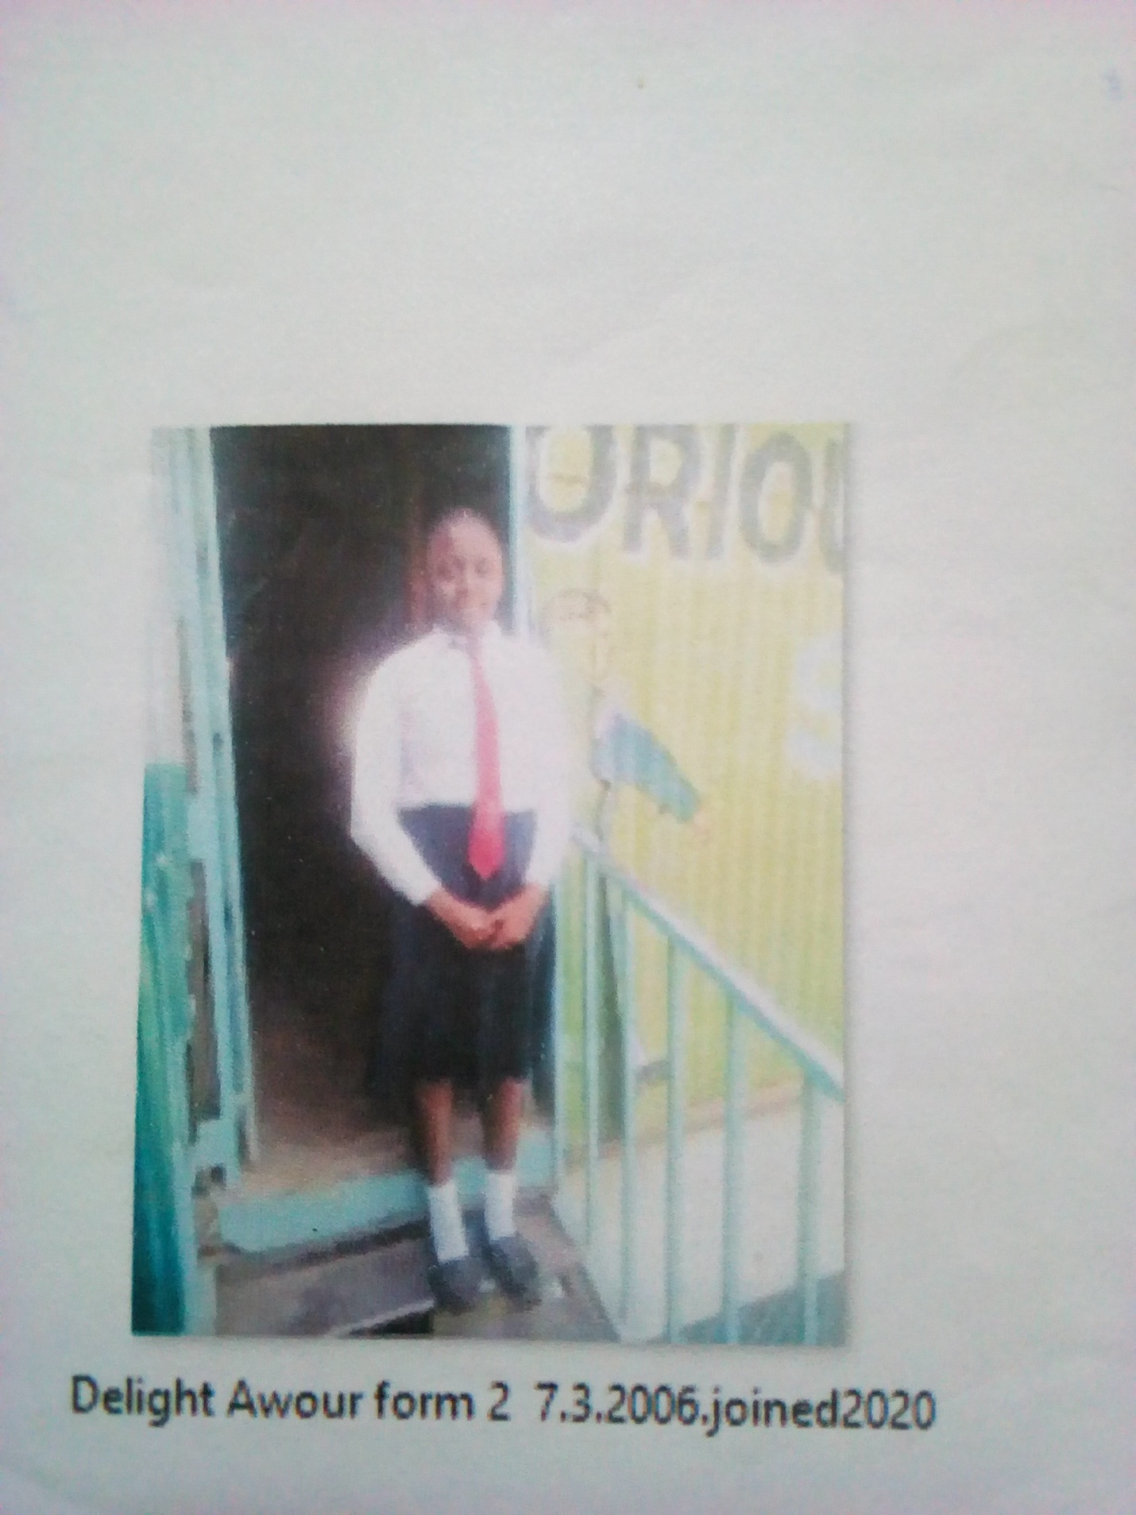
DELIGHT AWOUR FORM 2 BORN 2006 JOINED 2020
Delight 15 years was enrolled in our school when he was 14 years old. Delight is a needy child, her parents died in a tragic road accident. Delight was left homeless picked by Good Samaritan helped her for a short while but got tired in the long run. She sought help at Glorious school. She was accepted in school after the Director was contacted.
Thanks to the Director Mr. Boniface Mangeti who allowed Delight in school. I am now learning in glorious at least I have a place I call home praying that one day God will help our school have good classes, toilets and enough study materials. Thank you Michell and Brad for your support have really helped many in Mukuru

